🎨 Art Jokes 🎨
20 Curriculum-Linked Jokes
Each joke connects to a key learning point

Contents
1. Why did the artist go to jail? [Framing and presenting artwork]
2. Why was the painting always cold? [Drawing techniques and drafts]
3. What did the artist say to the wall? [Mixed media and plaster casting]
4. How does Salvador Dalí start his mornings? [Surrealism as an art movement]
5. Why did the crayon feel sad? [Warm and cool colour theory]
6. Why did Van Gogh become a painter? [Van Gogh: Post-Impressionist artist]
7. What do you call a painting done by a cat? [Portraiture: painting people and faces]
8. Why was the art student always calm? [Perspective drawing techniques]
9. What did the circle say to the square? [Elements of art: shape and form]
10. What's an artist's favourite swimming stroke? [Brushwork and painting techniques]
11. Why did the sculpture break up with the painting? [2D vs 3D art: painting vs sculpture]
12. What's red and bad for your teeth? [Tone and texture in artwork]
13. Why did the art teacher love autumn? [Complementary colours on the colour wheel]
14. What do you call art drawn on a fish? [Scale drawings and proportions]
15. Why did the pencil feel superior? [Pencil vs ink: revision in art]
16. What did Monet say to his garden? [Impressionism: Monet and light studies]
17. Why did the colour wheel go to the party? [The colour wheel: primary, secondary, tertiary]
18. What do you call an artistic ghost? [Character sketching and illustration]
19. Why was the abstract painting so confusing? [Abstract art: non-representational]
20. What's a vampire's favourite art medium? [Watercolour as a painting medium]

Joke #1
📌 Curriculum Link: Framing and presenting artwork

Q: Why did the artist go to jail?
A: They were framed!
💡 Discussion: Why is this joke funny? What does it tell us about "Framing and presenting artwork"? Can you explain the concept to a partner?

Joke #2
📌 Curriculum Link: Drawing techniques and drafts

Q: Why was the painting always cold?
A: Because it was in a draught! (draft/drawing)
💡 Discussion: Why is this joke funny? What does it tell us about "Drawing techniques and drafts"? Can you explain the concept to a partner?

Joke #3
📌 Curriculum Link: Mixed media and plaster casting

Q: What did the artist say to the wall?
A: One more crack and I'll plaster you!
💡 Discussion: Why is this joke funny? What does it tell us about "Mixed media and plaster casting"? Can you explain the concept to a partner?

Joke #4
📌 Curriculum Link: Surrealism as an art movement

Q: How does Salvador Dalí start his mornings?
A: With a surreal breakfast!
💡 Discussion: Why is this joke funny? What does it tell us about "Surrealism as an art movement"? Can you explain the concept to a partner?

Joke #5
📌 Curriculum Link: Warm and cool colour theory

Q: Why did the crayon feel sad?
A: Because its life was colourless without warm tones!
💡 Discussion: Why is this joke funny? What does it tell us about "Warm and cool colour theory"? Can you explain the concept to a partner?

Joke #6
📌 Curriculum Link: Van Gogh: Post-Impressionist artist

Q: Why did Van Gogh become a painter?
A: Because he didn't have an ear for music!
💡 Discussion: Why is this joke funny? What does it tell us about "Van Gogh: Post-Impressionist artist"? Can you explain the concept to a partner?

Joke #7
📌 Curriculum Link: Portraiture: painting people and faces

Q: What do you call a painting done by a cat?
A: A paw-trait!
💡 Discussion: Why is this joke funny? What does it tell us about "Portraiture: painting people and faces"? Can you explain the concept to a partner?

Joke #8
📌 Curriculum Link: Perspective drawing techniques

Q: Why was the art student always calm?
A: Because they knew how to draw a deep breath and use perspective!
💡 Discussion: Why is this joke funny? What does it tell us about "Perspective drawing techniques"? Can you explain the concept to a partner?

Joke #9
📌 Curriculum Link: Elements of art: shape and form

Q: What did the circle say to the square?
A: You're so edgy! Let's talk about shape and form.
💡 Discussion: Why is this joke funny? What does it tell us about "Elements of art: shape and form"? Can you explain the concept to a partner?

Joke #10
📌 Curriculum Link: Brushwork and painting techniques
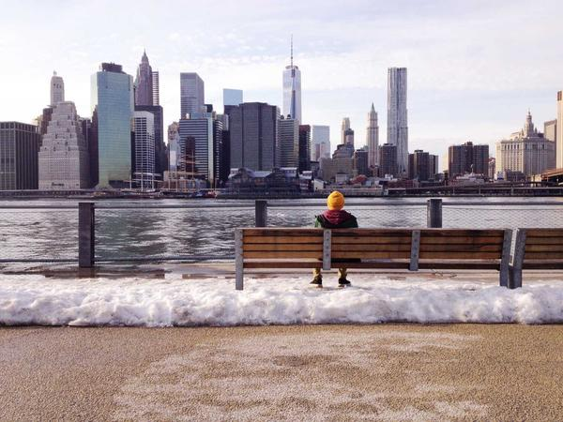
Q: What's an artist's favourite swimming stroke?
A: The brushstroke!
💡 Discussion: Why is this joke funny? What does it tell us about "Brushwork and painting techniques"? Can you explain the concept to a partner?

Joke #11
📌 Curriculum Link: 2D vs 3D art: painting vs sculpture
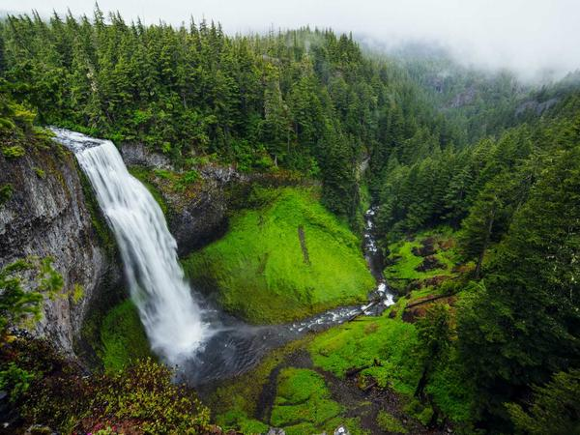
Q: Why did the sculpture break up with the painting?
A: It wanted a more three-dimensional relationship!
💡 Discussion: Why is this joke funny? What does it tell us about "2D vs 3D art: painting vs sculpture"? Can you explain the concept to a partner?

Joke #12
📌 Curriculum Link: Tone and texture in artwork

Q: What's red and bad for your teeth?
A: A brick — but in art, it's a study in tone and texture!
💡 Discussion: Why is this joke funny? What does it tell us about "Tone and texture in artwork"? Can you explain the concept to a partner?

Joke #13
📌 Curriculum Link: Complementary colours on the colour wheel

Q: Why did the art teacher love autumn?
A: Because of all the complementary colours — orange and blue!
💡 Discussion: Why is this joke funny? What does it tell us about "Complementary colours on the colour wheel"? Can you explain the concept to a partner?

Joke #14
📌 Curriculum Link: Scale drawings and proportions

Q: What do you call art drawn on a fish?
A: A scale drawing!
💡 Discussion: Why is this joke funny? What does it tell us about "Scale drawings and proportions"? Can you explain the concept to a partner?

Joke #15
📌 Curriculum Link: Pencil vs ink: revision in art

Q: Why did the pencil feel superior?
A: Because everything drawn in ink was permanent and it could still erase mistakes!
💡 Discussion: Why is this joke funny? What does it tell us about "Pencil vs ink: revision in art"? Can you explain the concept to a partner?

Joke #16
📌 Curriculum Link: Impressionism: Monet and light studies

Q: What did Monet say to his garden?
A: I'm going to make an impression of you!
💡 Discussion: Why is this joke funny? What does it tell us about "Impressionism: Monet and light studies"? Can you explain the concept to a partner?

Joke #17
📌 Curriculum Link: The colour wheel: primary, secondary, tertiary
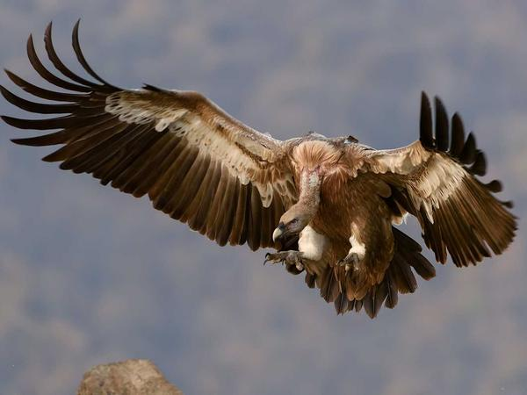
Q: Why did the colour wheel go to the party?
A: To bring some hue-mour!
💡 Discussion: Why is this joke funny? What does it tell us about "The colour wheel: primary, secondary, tertiary"? Can you explain the concept to a partner?

Joke #18
📌 Curriculum Link: Character sketching and illustration

Q: What do you call an artistic ghost?
A: A sketchy character!
💡 Discussion: Why is this joke funny? What does it tell us about "Character sketching and illustration"? Can you explain the concept to a partner?

Joke #19
📌 Curriculum Link: Abstract art: non-representational
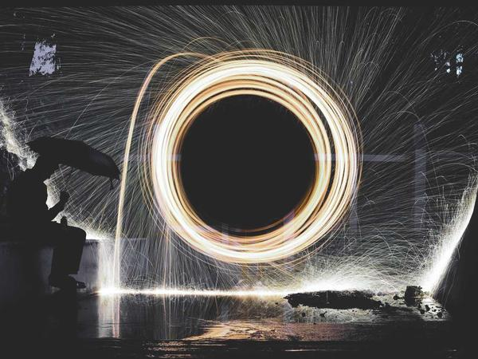
Q: Why was the abstract painting so confusing?
A: Nobody could figure out its point — that's the point!
💡 Discussion: Why is this joke funny? What does it tell us about "Abstract art: non-representational"? Can you explain the concept to a partner?

Joke #20
📌 Curriculum Link: Watercolour as a painting medium

Q: What's a vampire's favourite art medium?
A: Blood red watercolour! (or any wet medium)
💡 Discussion: Why is this joke funny? What does it tell us about "Watercolour as a painting medium"? Can you explain the concept to a partner?

